[Besiege Mod] Modern Air combat

**Manual**

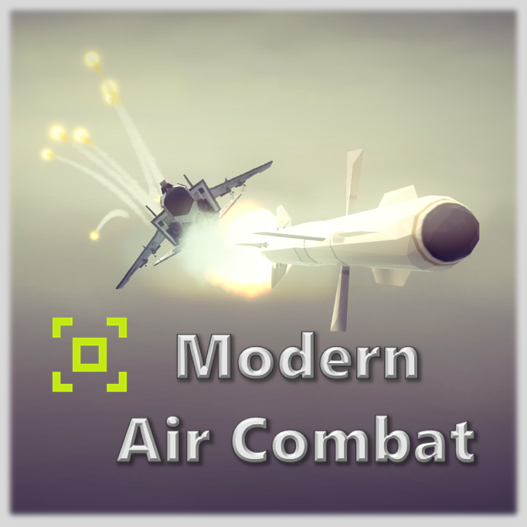

By

Chen, Yulin

[chenyulin@sjtu.edu.cn](mailto:chenyulin@sjtu.edu.cn)

Update: 2022/9/9

Contents

Overview 3

Objection 3

Feature 3

Blocks 3

SRAAM 4

Block status 4

Spotting strategy 5

MRAAM 6

Radar 7

General view 7

Adjust maximum scan angle 7

Adjust scanner pitch 8

Doppler feature 9

How to escape enemy radar 9

Displayer 10

Scan line 10

Target icon 10

Grid 10

Lock a target 11

HUD 13

Use HUD to shoot down an enemy 13

# Overview

## Objection

This mod concentrates on simulating modern air combat in Besiege, with a balanced trade-off between fidelity of simulation and performance cost.

## Feature

* Simulates the radar system on third generation fighter aircraft
* BVR attacking
* Nice particle systems for missile and flare.
* Low performance loss (so far)
* Tons of bugs (so far)

## Blocks

* SRAAM (short-range air-to-air missile)
* MRAAM (median-range air-to-air missile)
* Flare launcher
* Radar
* Radar display screen
* RWR alarm

# SRAAM

## Block status

Status.store

Default status, nothing more than a metal rod.

Status.launch

After press the launch button, it will enter this status.

There are two sliders that you can adjust:

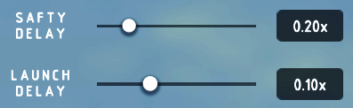

Unit: second

* Launch delay: after you press the button, the missile will first wait for some time and then start the missile engine.
* Safety delay: after the rocket engine is on, the missile will first wait for some time and then try to find targets and active proximity fuse. For high speed jet, adjust this to be bigger.

Mention:

The missile can still keep track of target after the engine stop, but a big diversion will cut down its speed a lot.

Status.explo

When there are colliders enter the range of proximity fuse, the missile will explode.

The PF range can be adjusted by:



Unit: meter

## Spotting strategy

The detecting region of the missile is a sphere in front of it with a radius of 550m.

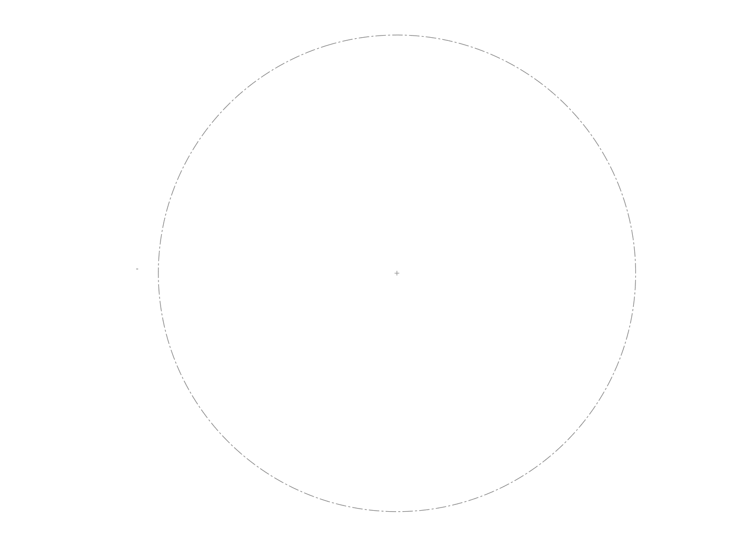

550

650

The missile will pick the 5th nearest (to the center of sphere) collider as the target and automatically aims to the target’s predicted position. The calculation rate of the predicted position is 50 times per second.

# MRAAM

MRAAM is inherited from SRAAM, so most of the functions are similar.

MRAAM receive information (including position and velocity) of the locked target from radar and calculate the predicted position. After launched, it will first fly to the predicted position (this position can be updated if the radar keeps scanning that target). When the distance of the missile and the predicted position is less than 1100m, the missile use its own spotting strategy just like SRAAM’s.

Mention:

If the radar hasn’t locked any target, the missile use its own spotting strategy immediately.

# Radar

To have an overview of the radar system on modern air fighter, you can refer to this website:

<https://tawdcs.org/radar-f15/>

Mention:

In this mod, the radar has Roll stability, i.e. the direction of the scanner will not be effected by your rolling maneuvers.

## General view

The general strategy of radar scanner is shown as following:

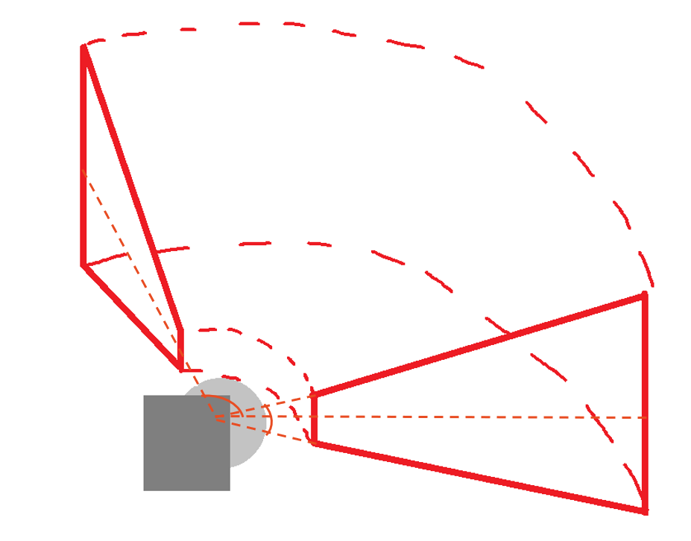

The maximum scan angle (β) of radar is 120 degree by default, on the left-right direction,

and the vertical angle (α) of the cross section is 20 degree.

β

**α**

## Adjust maximum scan angle

Each scan period (120 degree) takes 2s, meaning that the refreshing frequency is quite low, you can use displayer block to reduce the maximum scan angle (β) to increase the refreshing frequency.

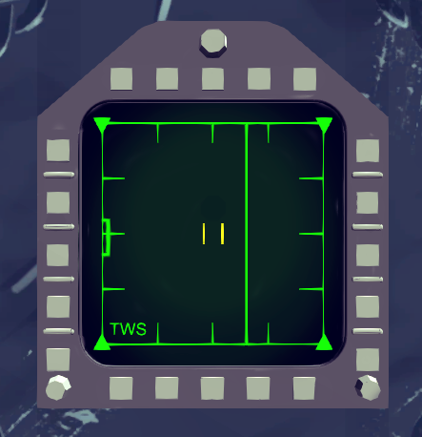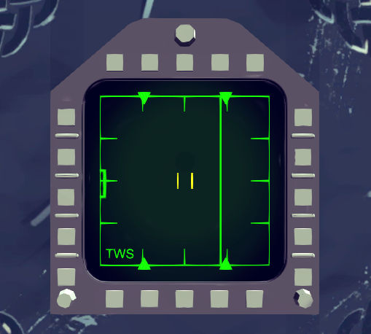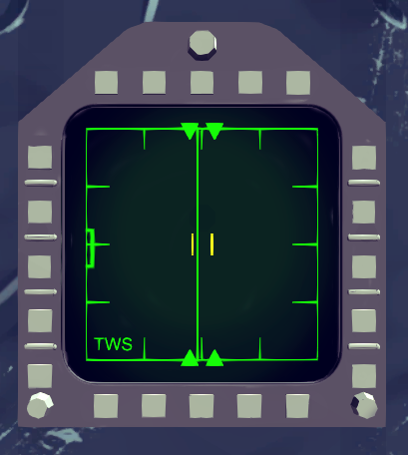

## Adjust scanner pitch

For these target that are above you or lower than you that you radar cannot detect, you can use displayer block to adjust your radar scanner’s relative pitch. Most of the time, you don’t need to adjust it manually.

The current scanner pitch is shown on the left of the screen

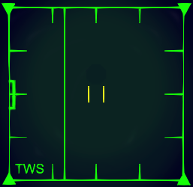

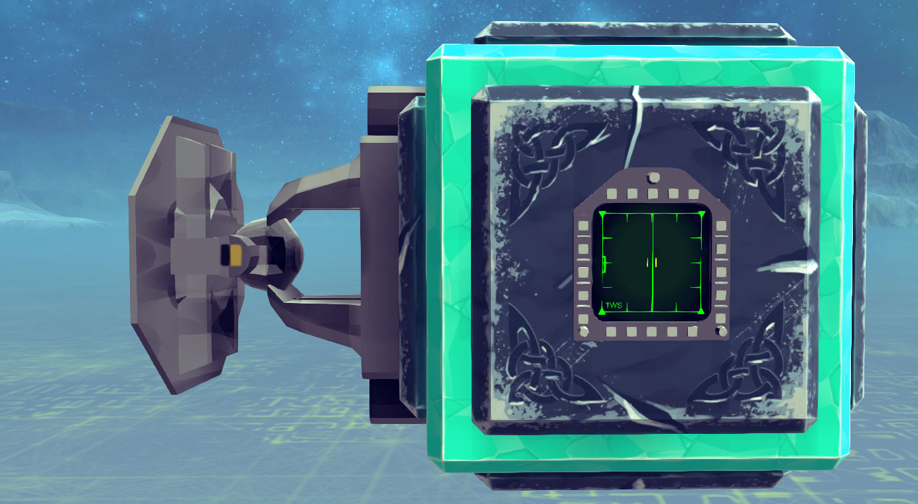

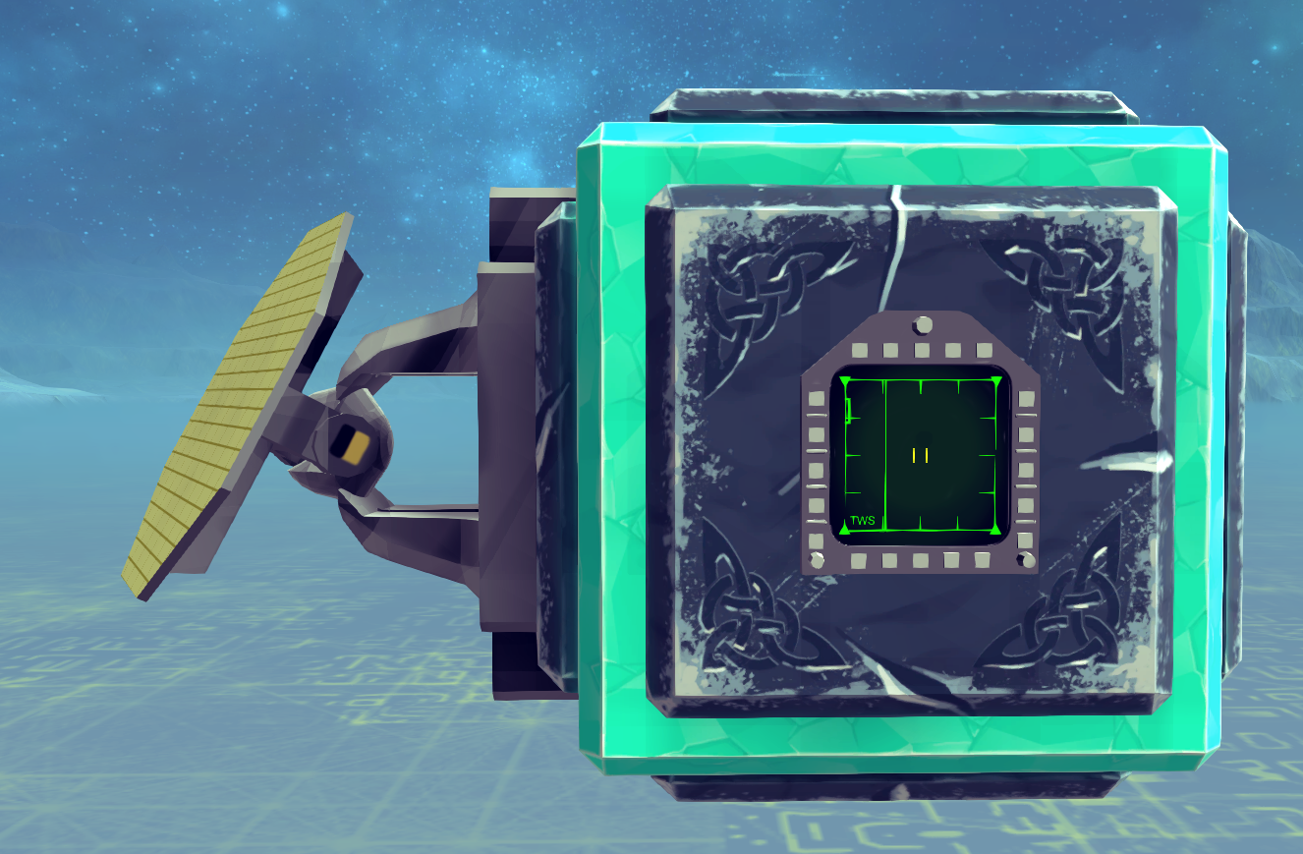

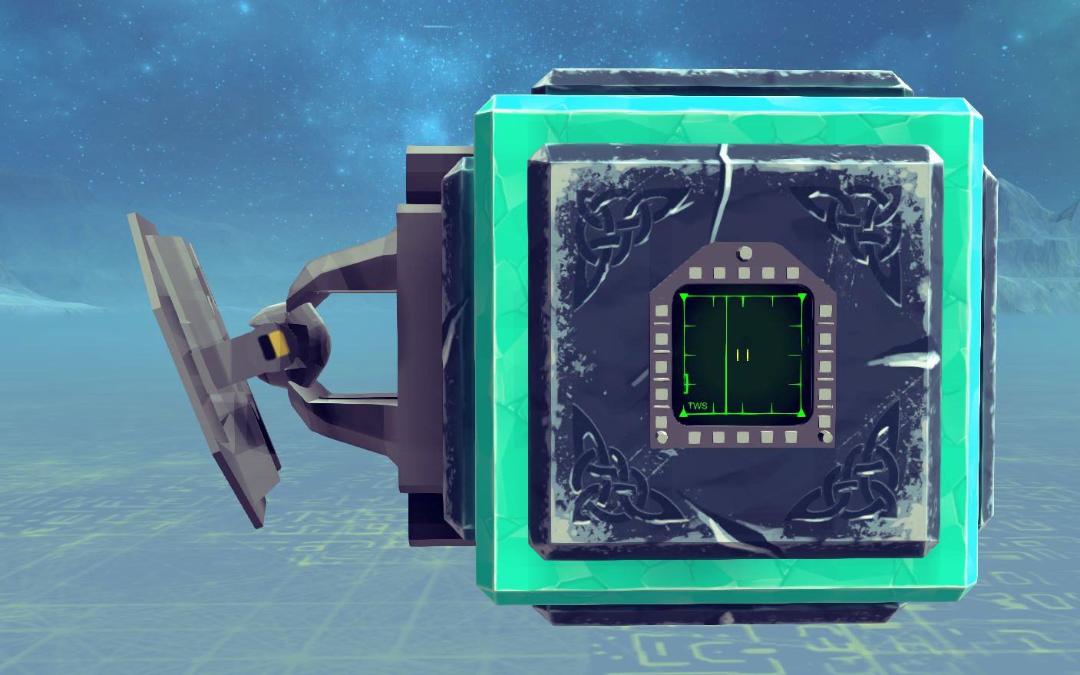

## Doppler feature

There is a toggle in radar named “DOPPLER FEATURE”



If it is on, the radar will filter out those targets that has roughly the same (difference lower than 35m/s) closing rate with ground and height lower than 500m, i.e. static blocks near ground will not be detected and your enemy can make use of this feature to escape your radar too!

## How to escape enemy radar

If the enemy’s doppler feature is on, keep the enemy plane at three or nine o 'clock (refer to your RWR block) and fly close to ground.

Why?

This can make your closing rate to enemy plane near to ground so that enemy radar will no consider you as a target.

No,you don’t.

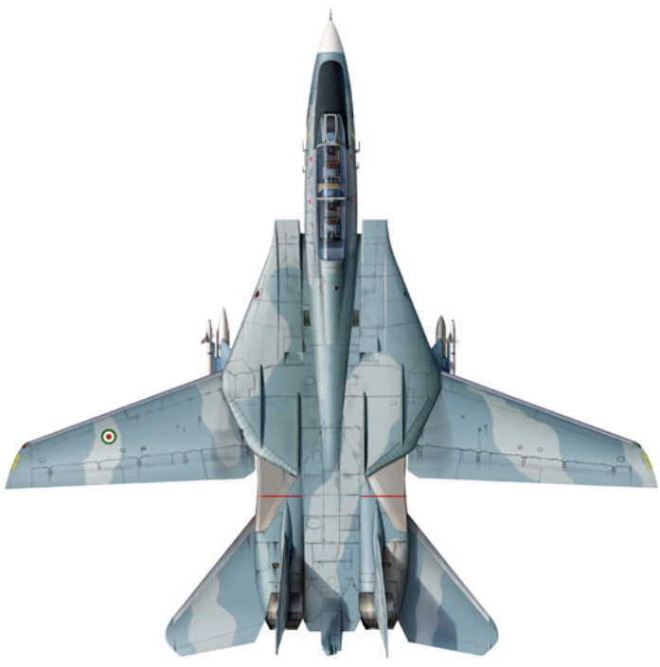 

Catch you!

# Displayer

## Scan line

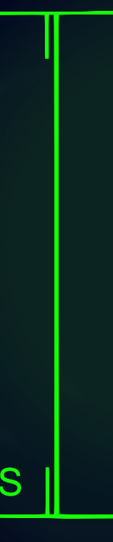

Indicates the current direction the radar is scanning.

## Target icon



Indicates a target that can be locked, updated when the scan line pass through its region.

## Grid

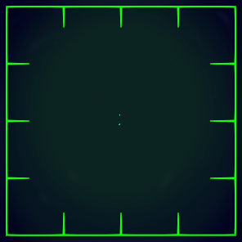

This grid is the base of the screen and is an angle-distance map. The scope of the horizontal axis is -60~60 degree. The scope of vertical axis is 0~12km.

For example, this means that there is a target ahead of you, with a distance 1500m.

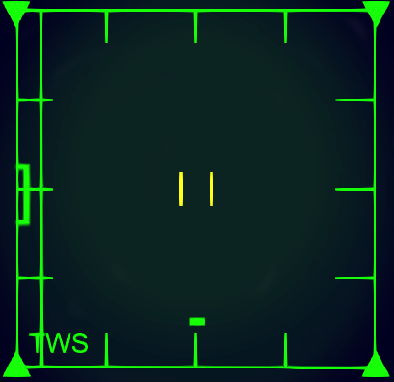

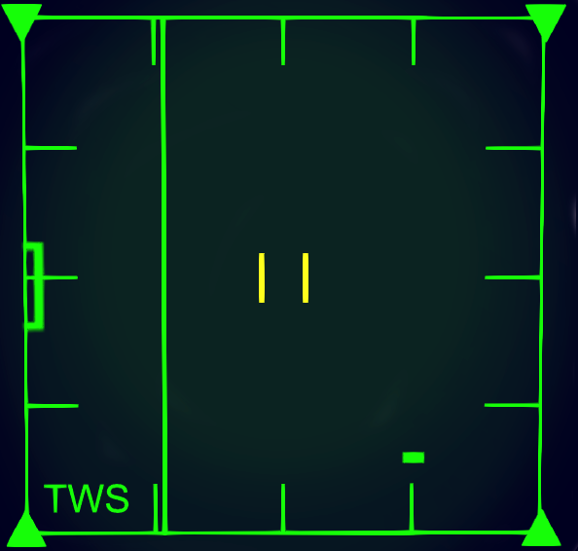

While this means that a target is on your 1 o’clock, with a distance 1500m.

## Lock a target

On your radar screen, you can find a yellow icon

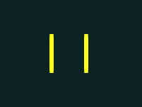

This is a target chooser, you can move it by press keys.

Move it near to the target displayed on the screen.

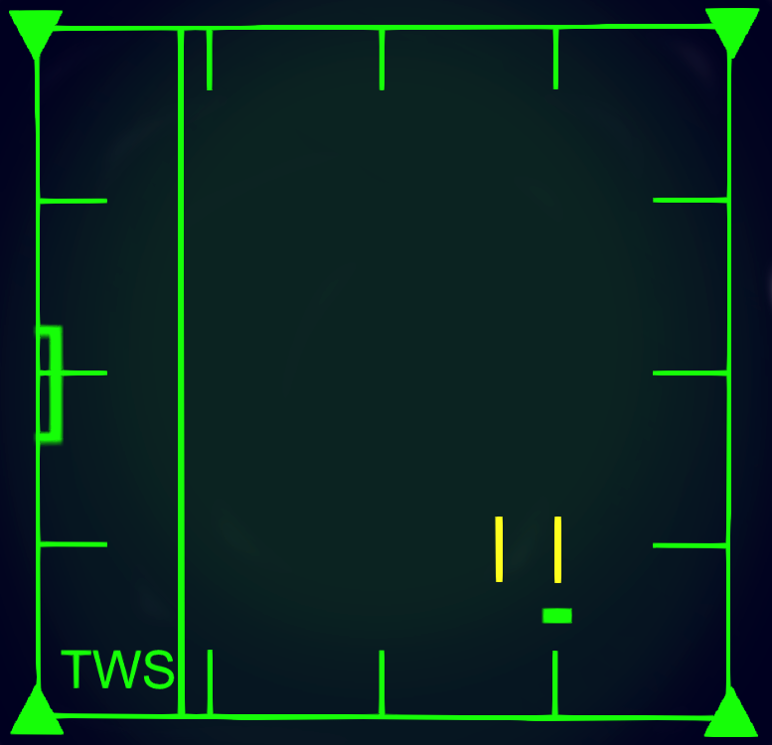

Then press the lock key.

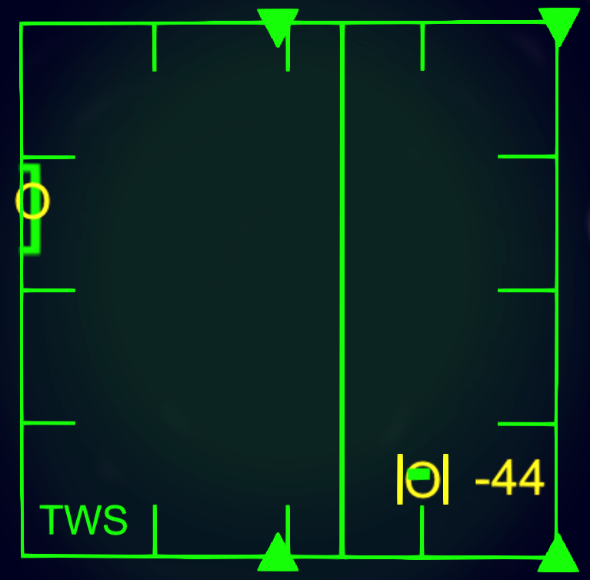

The target chooser will immediately move to the position of the target icon and a yellow ‘o’ will be added to it. The target chooser will keep track of the target.

The pitch of radar will be adjusted automatically to the relative pitch of the target. Also a yellow ‘o’ is added on the left of the grid, indicating the current relative pitch of the locked target.

Some yellow number appears on the right of the target chooser, indicating the current closing(m/s) rate of the locked target.

When the target is locked, it is recommended to reduce the maximum scan angle to increase the scan frequency.

Now it is time to launch your MRAAM.

You can press the lock key again to unlock the target, the radar scanner’s pitch will return to zero automatically.

# HUD

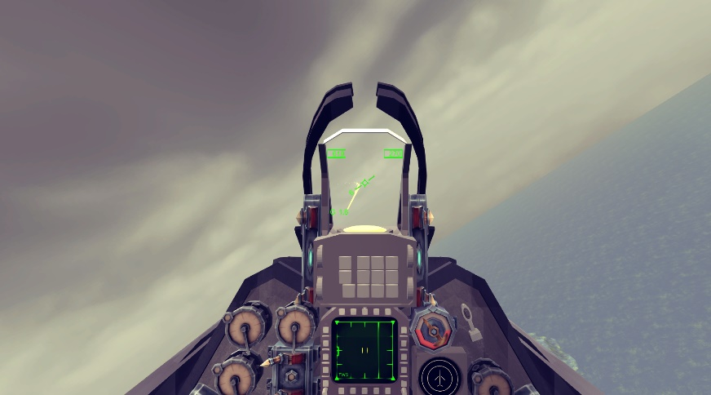

Hud shows many important information

* Speed (upper left), in kph
* Height (upper right), in meter
* Overload (lower left), in g
* Pitch, in degree
* Roll

When placing the HUD, make sure it is in the forward direction of your jet.

When placing the camera, make sure that the end point of your machine gun’s bullet is within the green aimer in the middle of HUD.

## Use HUD to shoot down an enemy

The HUD can help you to use your machine gun more efficiently, by provide precise target aimer (better if the target is within 0.8km).

Before simulation you need to input the initial speed of your machine gun in HUD.



Then use radar to lock a target.

You will see a circle appear on your HUD.

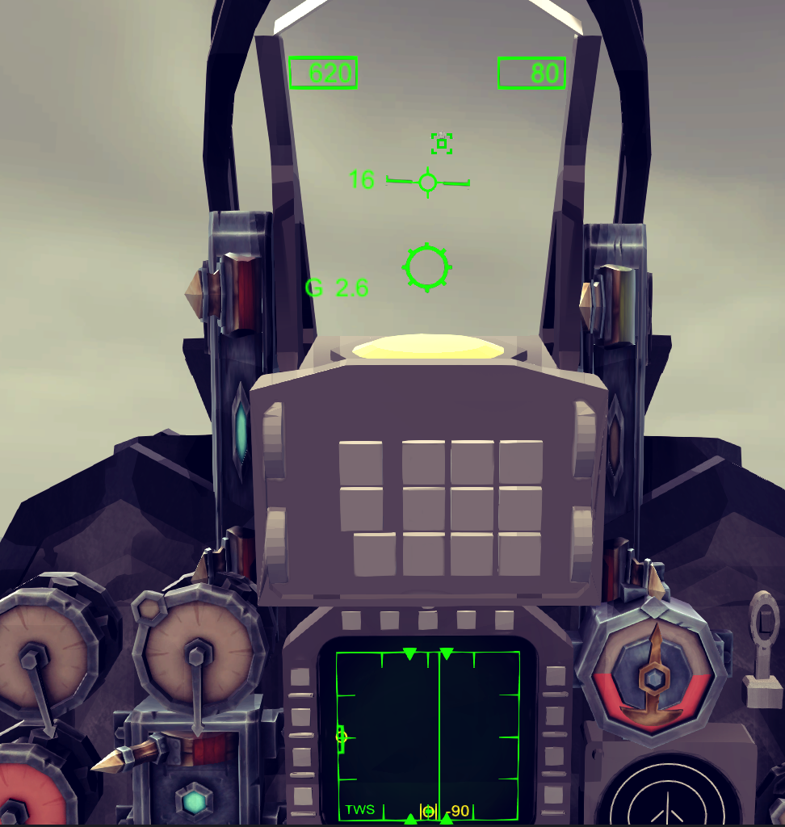

After that, what you need to do is just control your jet to hitch the enemy with the circle and fire.

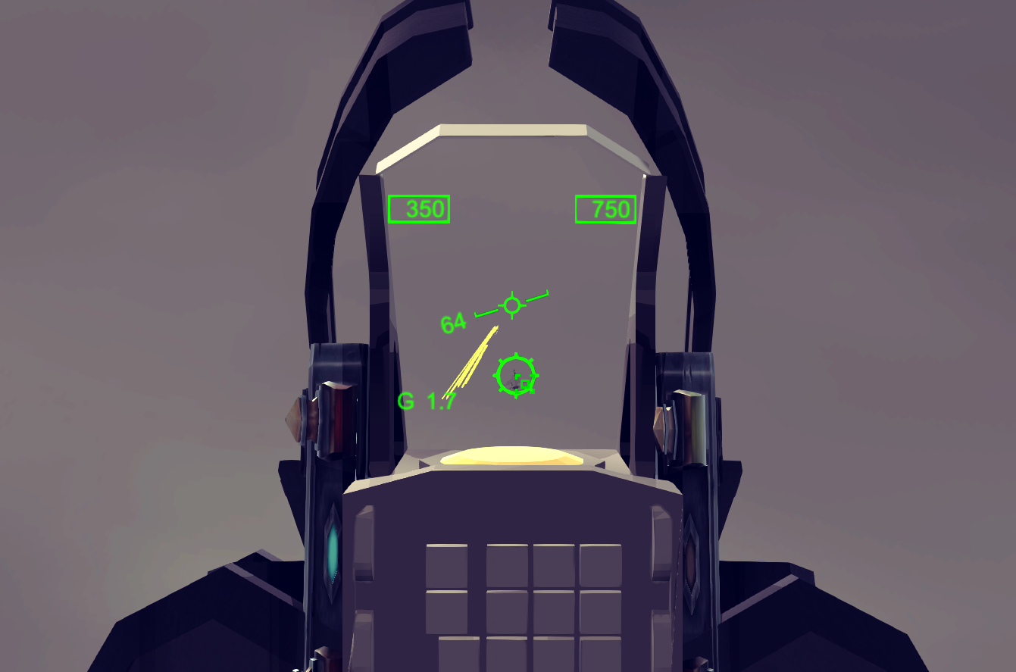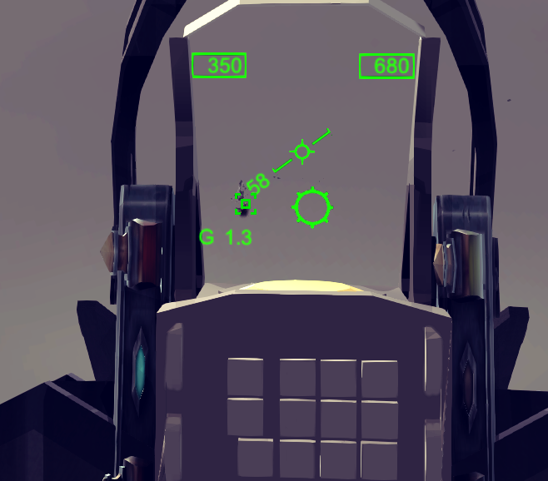

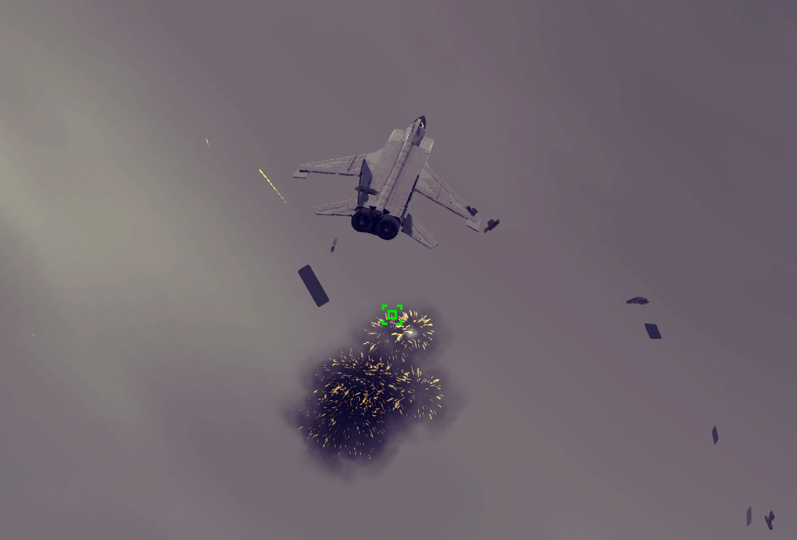

Mention

If the circular aimer become dotted, it means it’s beyond HUD’s range.

